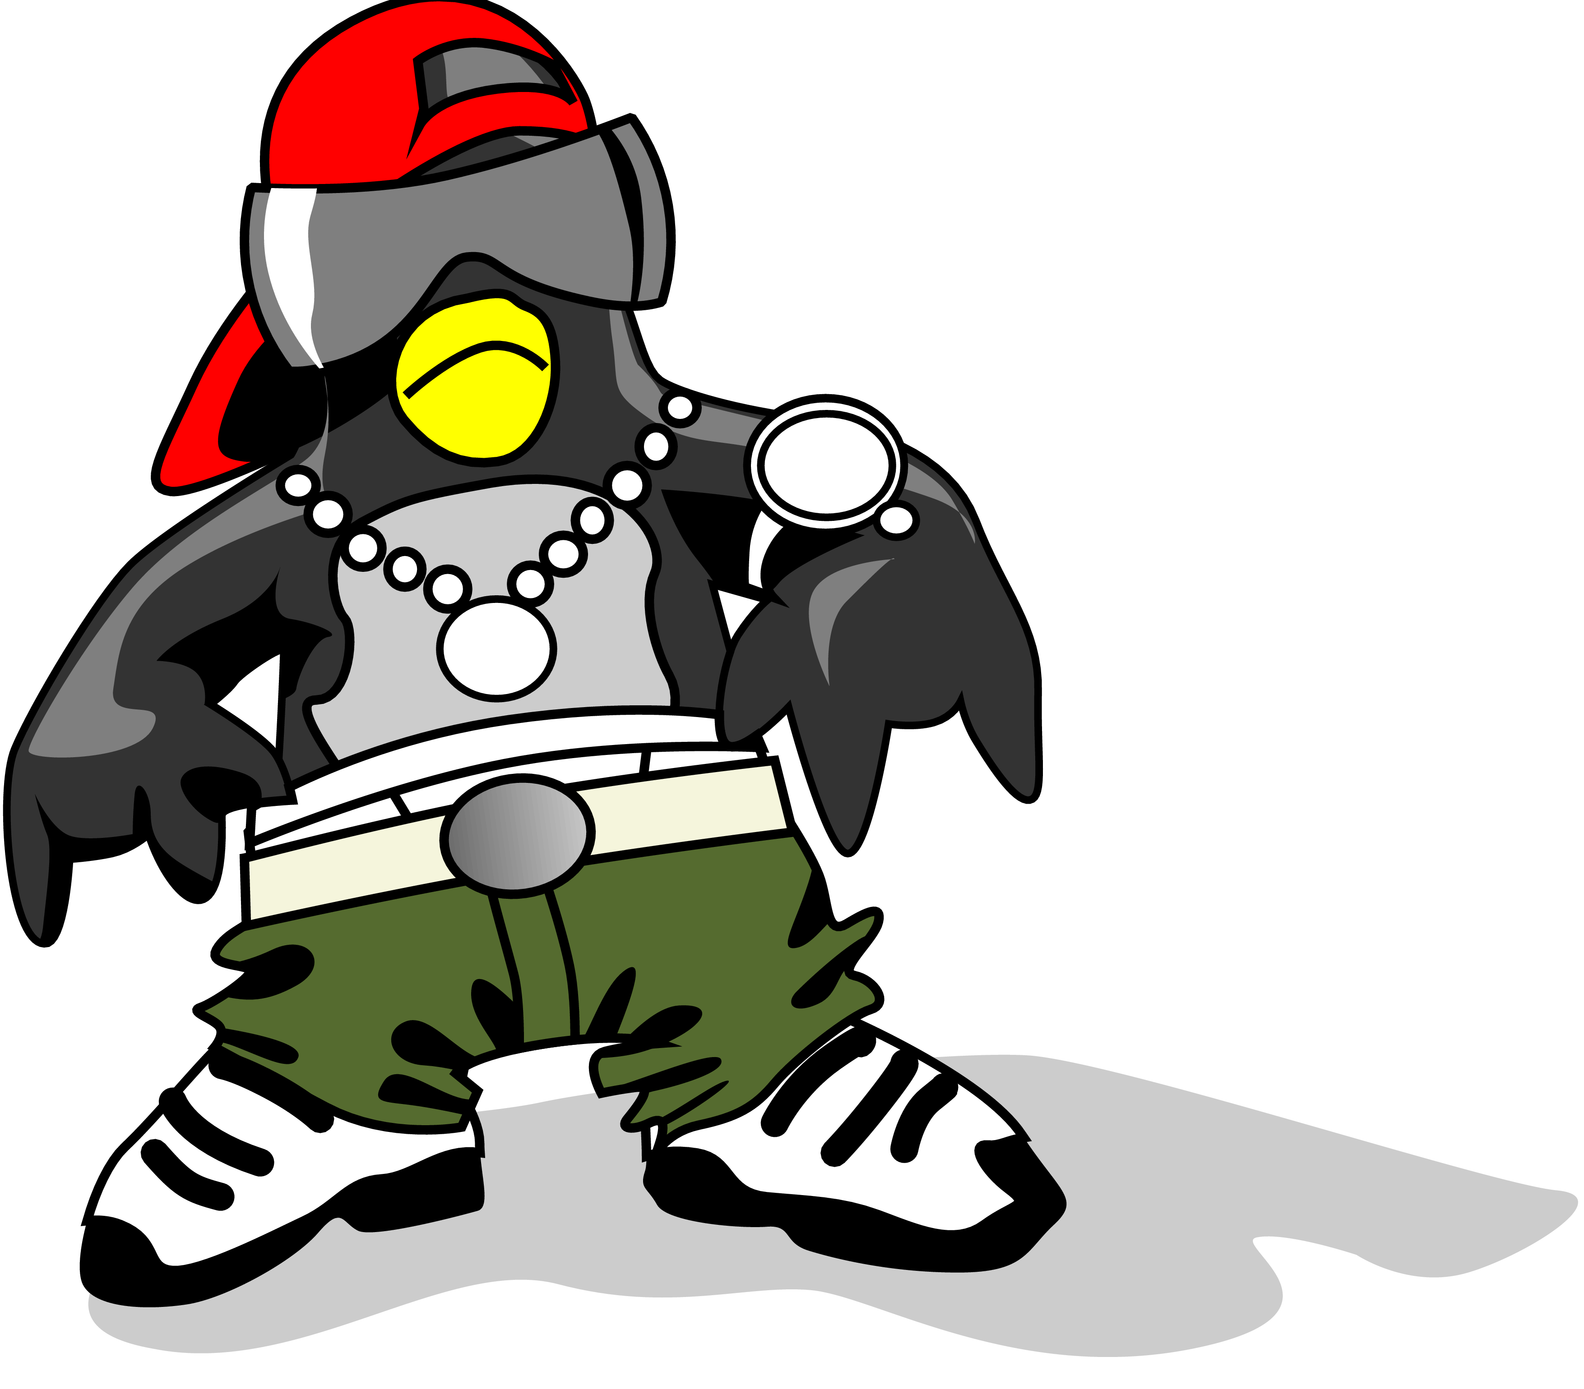
Yo mama’s so fat NASA thought the Earth had 2 moons!!!



Directions: Write your own fat mama jokes.

