- - Choose the suitable preposition from the list to complete the sentences : ( 2pts)
in front of – behind – in – opposite – below- on – next to – above - between
café Town hall supermarket  Abane Ramdane street  bank Restaurant Hospital Post Office  school library | 1-The café is ……the town hall.  2-The supermarket is……. the post office.  3-The hospital is……the restaurant and the library.  4-The school is…….the bank.

You want to go the bank, Complete the dialogue ( look at the map) ( 5 pts)
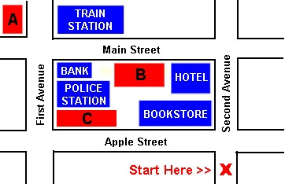 | You: Excuse me, ………… to the bank, please?  Policeman: ……………. Second Avenue to Main Street, then turn……….. The bank is the third……………on your…………, opposite the ……….and next to the………  You: ………………much.  Policeman: ............welcome.

